All Data fields for GE collected data from Bernoulli Research Devices and EHR data collected from IHIS database.

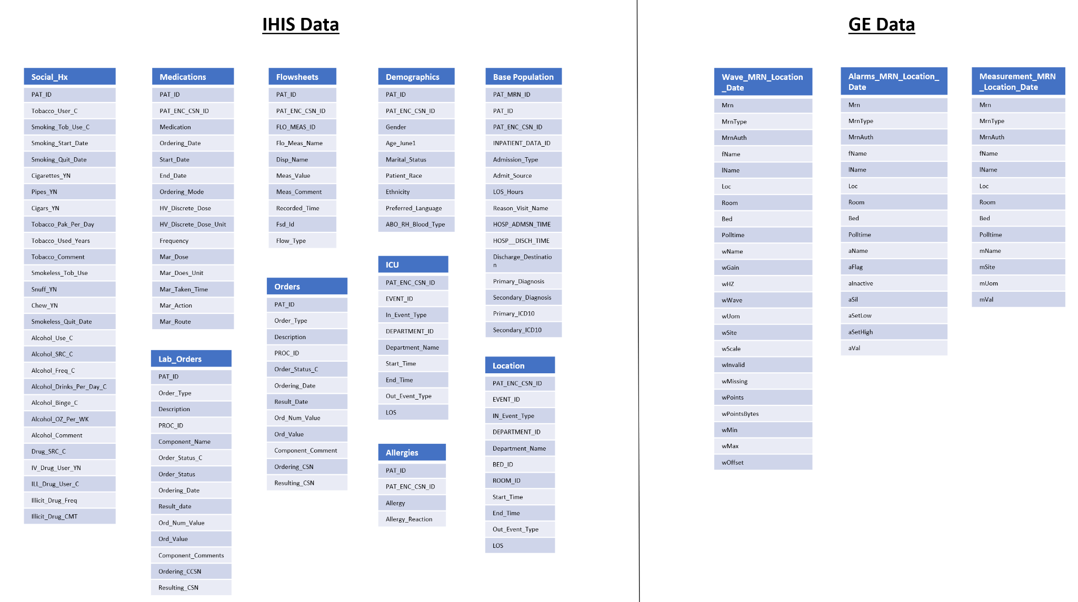

Format of the tables -

For the IHIS data, the data is collected at lower resolutions allowing all information for each patient to be collected in the same table.

For the GE data these tables had to be broken up into smaller tables to prevent them from growing too large. Therefore the measurements, alarms and waveforms tables are broken up into smaller tables titled by mrn_location_date. Where the table contains 24 hours of information related to a specific patient. When connecting information to the EHR data, it may be advisable to union patient tables together.

Joining information collected from the Bernoulli Research devices to the EHR data can be done through the deidentified MRN field.

While this can be enough, it is suggested to perform a couple of checks.

1) Does the time frame which is captured for waveforms, measurements, and alarms for a specific deidentified MRN match the location, bed, and room along with hospital admission and discharge time for the matching deidentified MRN in the EHR data? Some cropping of the measurements data may need to be done if measurements extend past a hospital discharge or a transfer to a different location.

Note – what is captured by the Bernoulli Research devices will often only be a subset of data from their total stay.

2) It may be useful to check how well the recorded measurements match validated RR, HR, SPO2, etc. that are recorded within the flowsheets table.

3) Flowsheets contain unique events, such as ERT calls within them. For the event in interest, it may be necessary to ensure that event happened while the patient was in a bed that was being recorded by a Bernoulli Research Device.